* Handling Globally Exception
* VD1: custom API error object

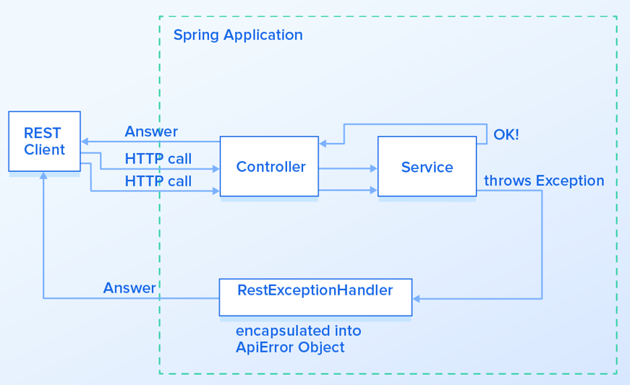

*Flow*

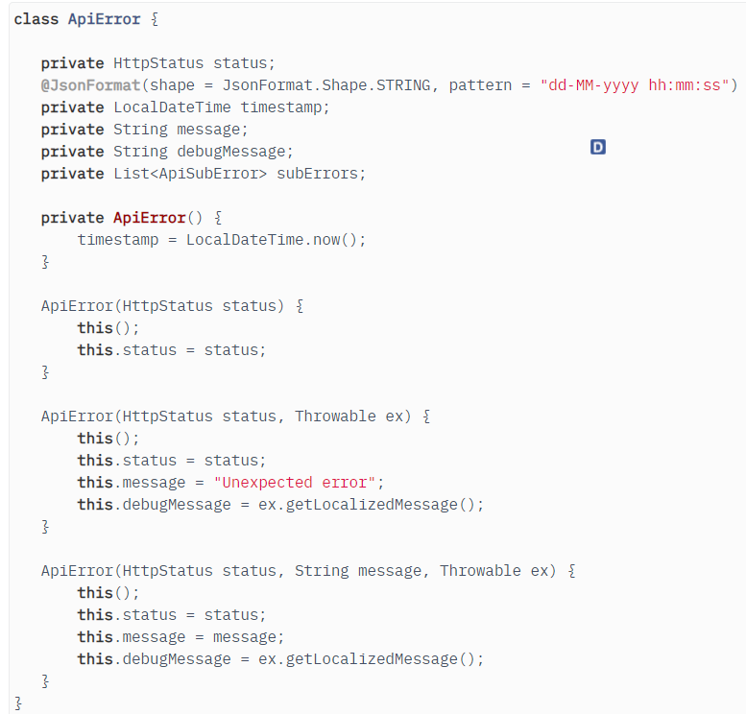 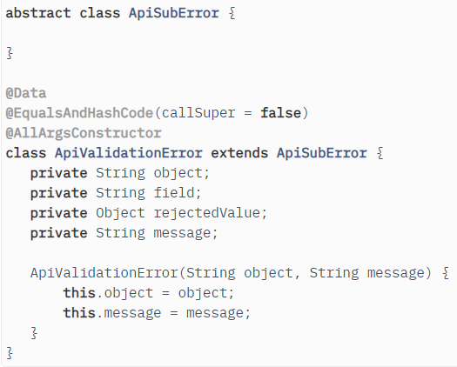

*Error object*

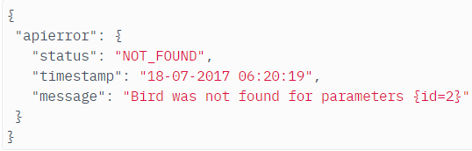 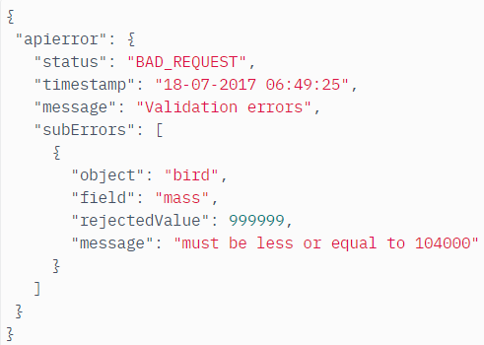

*API*

* **VD2: Custom available Exception**

Default thì spring sẽ handle exception theo ResponseEntityExceptionHandler

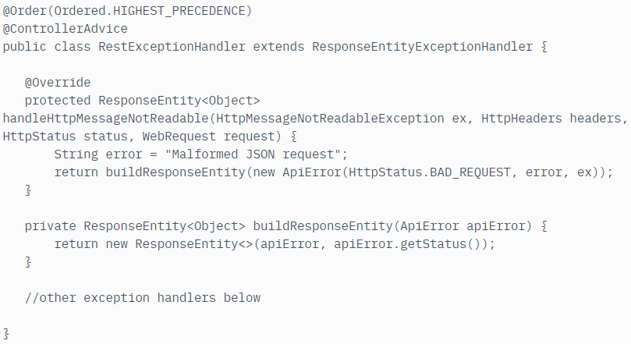

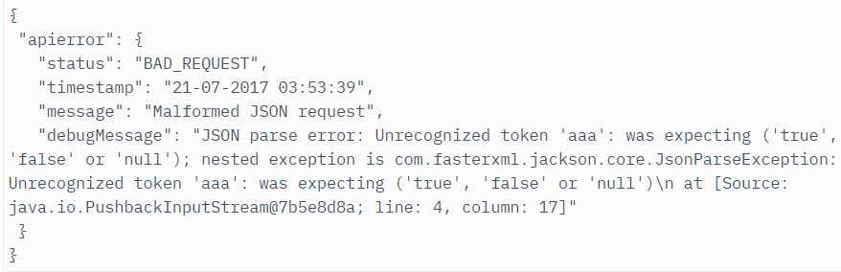

* + **Handling custom Exception**

VD:

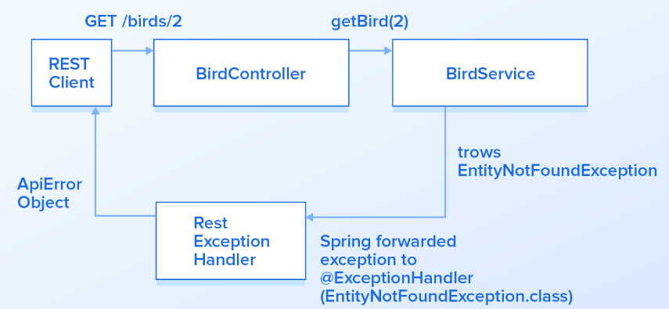

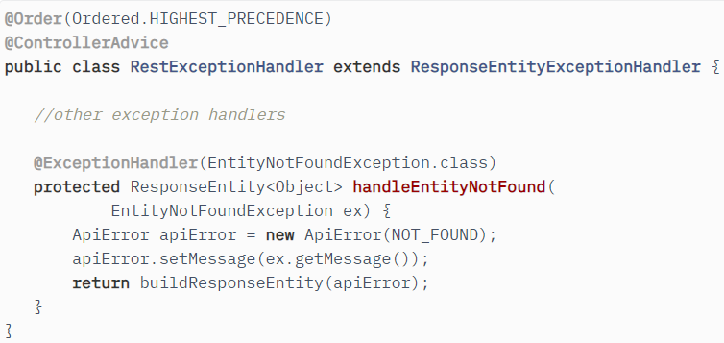 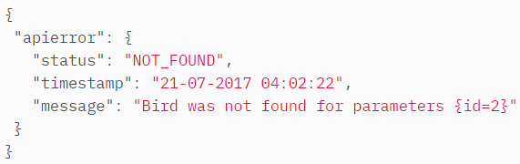

* **Reference**

<https://www.toptal.com/java/spring-boot-rest-api-error-handling>

<https://reflectoring.io/bean-validation-with-spring-boot/#returning-structured-error-responses>